# Stolen Object Tracker

## User Manual

### Server

#### Installation:

##### Database Setup:

Login Credentials:

User = root

Password = toor

* User and Password can be changed, but make sure to also update

the credentials used in the database.go source file. (This requires the program to be recompiled)

Create a new MySQL database named "trackerdb" (database name can be changed, but must also be updated in the database.go source code).

Import SQL dump (if you know how to do it on your own skip this step).

Command Line:

Change to directory containing trackerdb.sql

mysql --user=name database_name < trackerdb.sql

Database setup is now complete.

##### Server Setup:

NOTE: The server executable can be in any directory, but the directories

in step 2 must also be in the same directory as the executable.

Make sure that the database is running before running the server.

Copy the following directories to the same directory that the server executable is located.

* /css

* /images

* /js

* /templates

Run the SMS gateway application and connect to the server's IP address using port 10016.

Once the database and the SMS gateway are running, you can now execute the server executable.

### SMS Gateway

#### Installation:

Copy the SMSGateway.APK to your Android smart phone.

Navigate to it in the 'Files' app and select it.

Install it with the package installer.

#### Use:

Run the app.

Enter the IP address and port of the server you want to connect to.

The default port on the server to use is 10016.

Press 'Connect'.

When you want to disconnect, press 'Disconnect'.

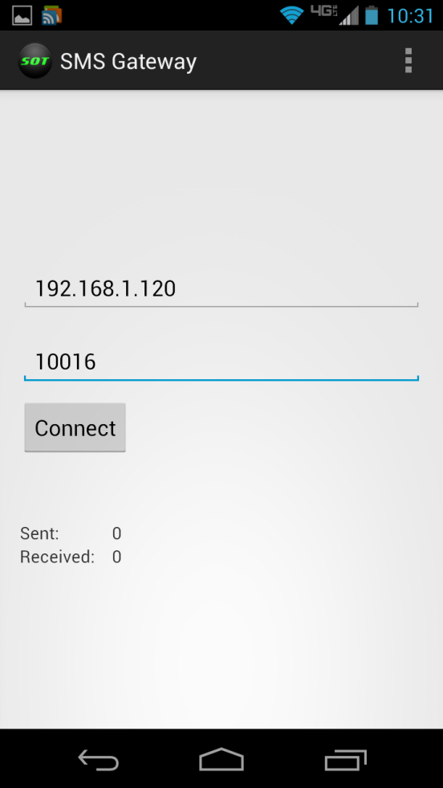

### Geogram One

#### Use:

The Geogram One should be usable out of the box. Simply plug it in and register it on the website.

If the PIN has changed, return it to the default ‘1234’ value.

#### Installing Firmware:

In the event that the Geogram One is on an incompatible firmware version, a version that is known to work with the system can be installed.

Geogram One resources can be found here: <http://www.dsscircuits.com/>

Firmware installation instructions can be found here: <http://www.dsscircuits.com/forum/index.php/topic,34.0.html>

### Windows Service and Keylogger

#### Windows Service installation:

Open command prompt in administrator mode and navigate to the directory containing WindowsServiceTracker.exe

Use the command 'WindowsServiceTracker.exe --install'

The service will start automatically on windows startup from now on (so you may want to restart now)

#### Uninstallation:

Open command prompt in administrator mode and navigate to the directory containing WindowsServiceTracker.exe

Use the command 'WindowsServiceTracker.exe --uninstall' if you ever need to uninstall

After the service is run for the first time, it will generate an ID.txt file int the directory it was installed from. Use that ID to register your device on the server.

Additionally, in the folder that contains WindowsServiceTracker.exe, there is a file, WindowsServiceTracker.exe.xml. There are 3 settings in this file. one is the port number, it is by default 10015 and will most likely not need to be changed. The others are an IP address and Domain name. By default the IP address points to your computer and the domain name is invalid. Set either of these values to the server you wish to connect to. The domain name takes precedence over the IP address when connecting and is the preferred method. Any changes to this file will require a restart of the service to take effect. If you are distributing this service, you will likely want to set these values for your users and tell them to disregard this file.

#### Keylogger installation:

Navigate to the directory (in Windows explorer) containing 'WTKL.exe'

Right click 'WTKL.exe' and select 'Properties'. Select the 'Compatibility' tab, select 'Change settings for all users', select 'Run this program as an administrator', then apply changes.

Right click 'WTKL.exe' and select 'create shortcut'

place the shortcut in

Windows 7: 'C:\Documents and Settings\All Users\Start Menu\Programs\Startup'

In the Control Panel find the "Programs and Features" page. Once there click on "Turn Windows features on or off". A new window with title "Windows Features" will appear. Scroll down to ".NET Framework 4.5 Advanced Series" and expand it. Expand "WCF Services". Check "Named Pipe Activation" if it is not already check. Click "OK" to close the window and activate the feature.

Additionally, under "Turn Windows features on or off" in the same window, expand the "Microsoft .NET Framework 3.5" option (the name may differ slightly) and enable both options, "Windows Communication Foundation HTTP Activation" and "Windows Communication Foundation Non-HTTP Activation"

Restart your computer.

#### Uninstallation:

Delete the shortcut to uninstall

### Website

#### Use:

To access the website, open a modern browser and type the IP address of the server in the address bar followed by “:8080”. An example is “79.117.86.121:8080”. Alternately, you can enter the domain name if the server has one.

If you have not recently logged on to the server, you will be taken to the home page. You have the option to create an account on the left or log into an existing account on the right.

After logging into an account you are brought to the map page. Here you have the option to add devices, view device data, and logout.

Use the devices dropdown menu to either add a new device or view existing ones.

When adding a device, select either “GPS Device” or “Laptop Device” depending on the device you are registering. The device name is customizable and to be chosen by you. The ID is either the phone number, if it is a Geogram One device or the ID assigned by the Service if it is a laptop.

Selecting a device from the dropdown menu will generate controls for the device on the right of the screen.

For laptops:

* Activate: Begin keylogging and reporting IP addresses
* Deactivate: End keylogging and reporting IP addresses
* Show IP Addresses: Display a list of IPs that the laptop has connected from. The first number is the IP that the server sees the laptop as and will usually be all the information needed. In the case that laptop is connecting through a proxy or something similar, that IP address could be wrong. The following IP addresses show the route the laptop uses to communicate to the server over the Internet and can be used to get next-best IPs for the laptop.
* Show Keylogs: Display a list of keylogs gathered from the laptop.

For GPS devices:

* Activate: Begin tracking (location updates) on motion and once every 24 hours if not woken by motion.
* Deactivate: End tracking.
* Show Coords: Displays coordinates of the GPS device with timestamps.
* Ping: Wake the Geogram temporarily.
* Toggle Locations: Toggle the location markers for this device on or off.